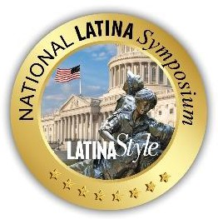

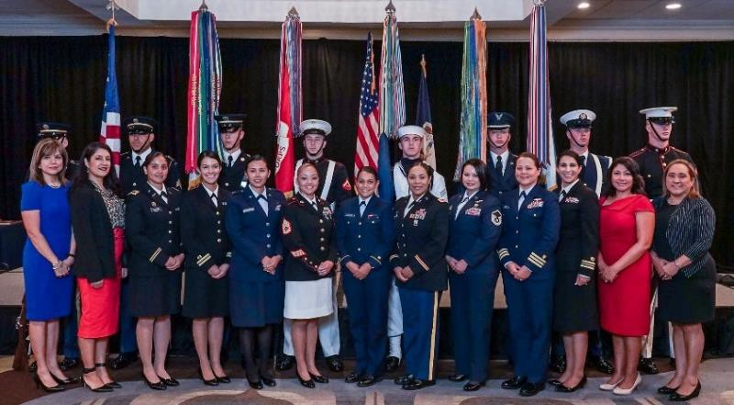

- The 2024 LATINA Style Distinguished Military Service Awards recognize and celebrate the accomplishments of women in the military, Department of Defense civilian workforce, and Service Academies who have enhanced the role of Latinas in their organization, DoD, and Academy. The criteria for the award are as follows:

  - Active Duty (Officer/Enlisted) nominees should:
  - Distinguish themselves as leaders, mentors, and advocates of diversity, promoting the full integration of Hispanic women in the Armed Forces.
  - Embody the qualities that align with the core mission of their Service.
  - Command respect from superiors, peers, and community leaders.
  - Represent the Hispanic community with dignity and pride.
  - Civilian nominees:
  - Embody the qualities that align with the core mission of their organization.
  - Contribute to creating opportunities and careers that support and advance Hispanic Americans.
  - Display exceptional character and represent the Hispanic community with dignity and pride.

  - Cadet or Midshipmen nominees:
- Distinguish themselves in leadership and academics, advocating for diversity and the full integration of Hispanic women.
- Embody the qualities at the core of the Service Academy's mission.
- Command respect from superiors, peers, and community leaders.
- Represent the Hispanic community with dignity and pride.

2. Approval Authority: Commanders within the member’s direct chain of command may serve as the approval authority for nominations. Organization and service representatives should screen the nominations and ensure that they meet the above criteria. Each organization and service may nominate more than one military service member, civilian, and cadet nominee, but only one will be selected for each award.

3. Award Presentation: The award will be presented during the Distinguished Military Service Award Program, which will take place during the 21st Annual National LATINA Symposium scheduled for September 2024 in Washington, D.C. All nominees are invited to attend the event.

- Nomination Process: Each service and organization must provide guidance to their respective installation, base, or garrison with internal suspense dates and nomination procedures as applicable. Military and Civilian award nominations should be submitted directly to their respective service branch's DEI (Diversity, Equity, and Inclusion) office, and then forwarded to LATINA Style no later than Friday, June 7, 2024. Academy nomination packages may be submitted directly to LATINA Style for consideration at nls@latinastyle.com, with a courtesy copy to Robert E. Bard at robertbard@latinastyle.com, also no later than Friday, June 7, 2024.

If you have any questions or would like additional information, please visit nlslatinastyle.com or you can reach us at 214-357-2186.

The selection process for the LATINA Style Distinguished Military Service Award will be based on the criteria outlined below:

- Cover or Transmittal Memorandum: Each nomination should include a cover or transmittal memorandum, which can be provided in a scanned or PDF format.

- Award Nomination Transmittal Form: Nominees are required to complete and submit the Award Nomination Transmittal Form (details provided separately).

- Narrative Description: A single-spaced narrative not exceeding two pages in Microsoft Word format is to be provided. This narrative should describe the nominee's accomplishments in the past twelve months, highlighting achievements that best reflect and represent the recognition of the LATINA Style Distinguished Military Service Award. The narrative must be typed in 12-pitch font, with 1-inch left and right margins. Scanned or PDF formats will not be accepted.

- Award Citation: An award citation is required, highlighting the nominee's accomplishments in the past twelve months. This citation should be submitted in a Microsoft Word document, with a narrative not exceeding 18 lines, typed in 12-pitch font, and with 1-inch left and right margins. Scanned or PDF formats are not acceptable.

- Nominee Biography: A single-spaced biography of the nominee, not exceeding one page in length, should be submitted in Microsoft Word format. Scanned or PDF formats are not acceptable.

- Digital Photograph: A high-resolution, color, head-and-shoulder portrait photograph of the nominee in service uniform is to be provided in JPEG format.

- Eligibility Period: The eligibility period for the 2024 LATINA Style Distinguished Military Service Award spans from June 2023 to June 2024.

The selection committee will consider all these components to assess and recognize the outstanding accomplishments of nominees for the LATINA Style Distinguished Military Service Award. Please ensure that all materials are prepared and submitted in accordance with the specified formats and guidelines to facilitate the evaluation and selection process.

Award Nomination Transmittal Form

NOMINEE'S INFORMATION

Name:
Position Title or Grade:
DoD Component/Organization:

Mailing Address:

Work Phone Number: Fax Number: Email Address:

NOMINATING OFFICIAL'S INFORMATION

Name:

Position Title or Grade:

DoD Component/Organization:

Mailing Address:

Work Phone Number: Fax Number:
Email Address:

